UNITED STATES
SECURITIES AND EXCHANGE COMMISSION
Washington, D.C. 20549

SCHEDULE 14A
(Rule 14a-101)
Proxy Statement Pursuant to Section 14(a) of the Securities Exchange Act of 1934 (Amendment No. )

Filed by the Registrant | ☒ |  | Filed by a party other than the Registrant | ☐

Check the appropriate box:

☐ |  | Preliminary Proxy Statement
☐ |  | Confidential, for Use of the Commission Only (as permitted by Rule 14a-6(e)(2))
☐ |  | Definitive Proxy Statement
☒ |  | Definitive Additional Materials
☐ |  | Soliciting Material under § 240.14a-12

World Kinect Corporation
(Name of Registrant as Specified in its Charter)

(Name of Person(s) Filing Proxy Statement, if Other Than the Registrant)

Payment of Filing Fee (Check all boxes that apply):

☒ |  | No fee required
☐ |  | Fee paid previously with preliminary materials
☐ |  | Fee computed on table in exhibit required by Item 25(b) per Exchange Act Rules 14a-6(i)(1) and 0-11

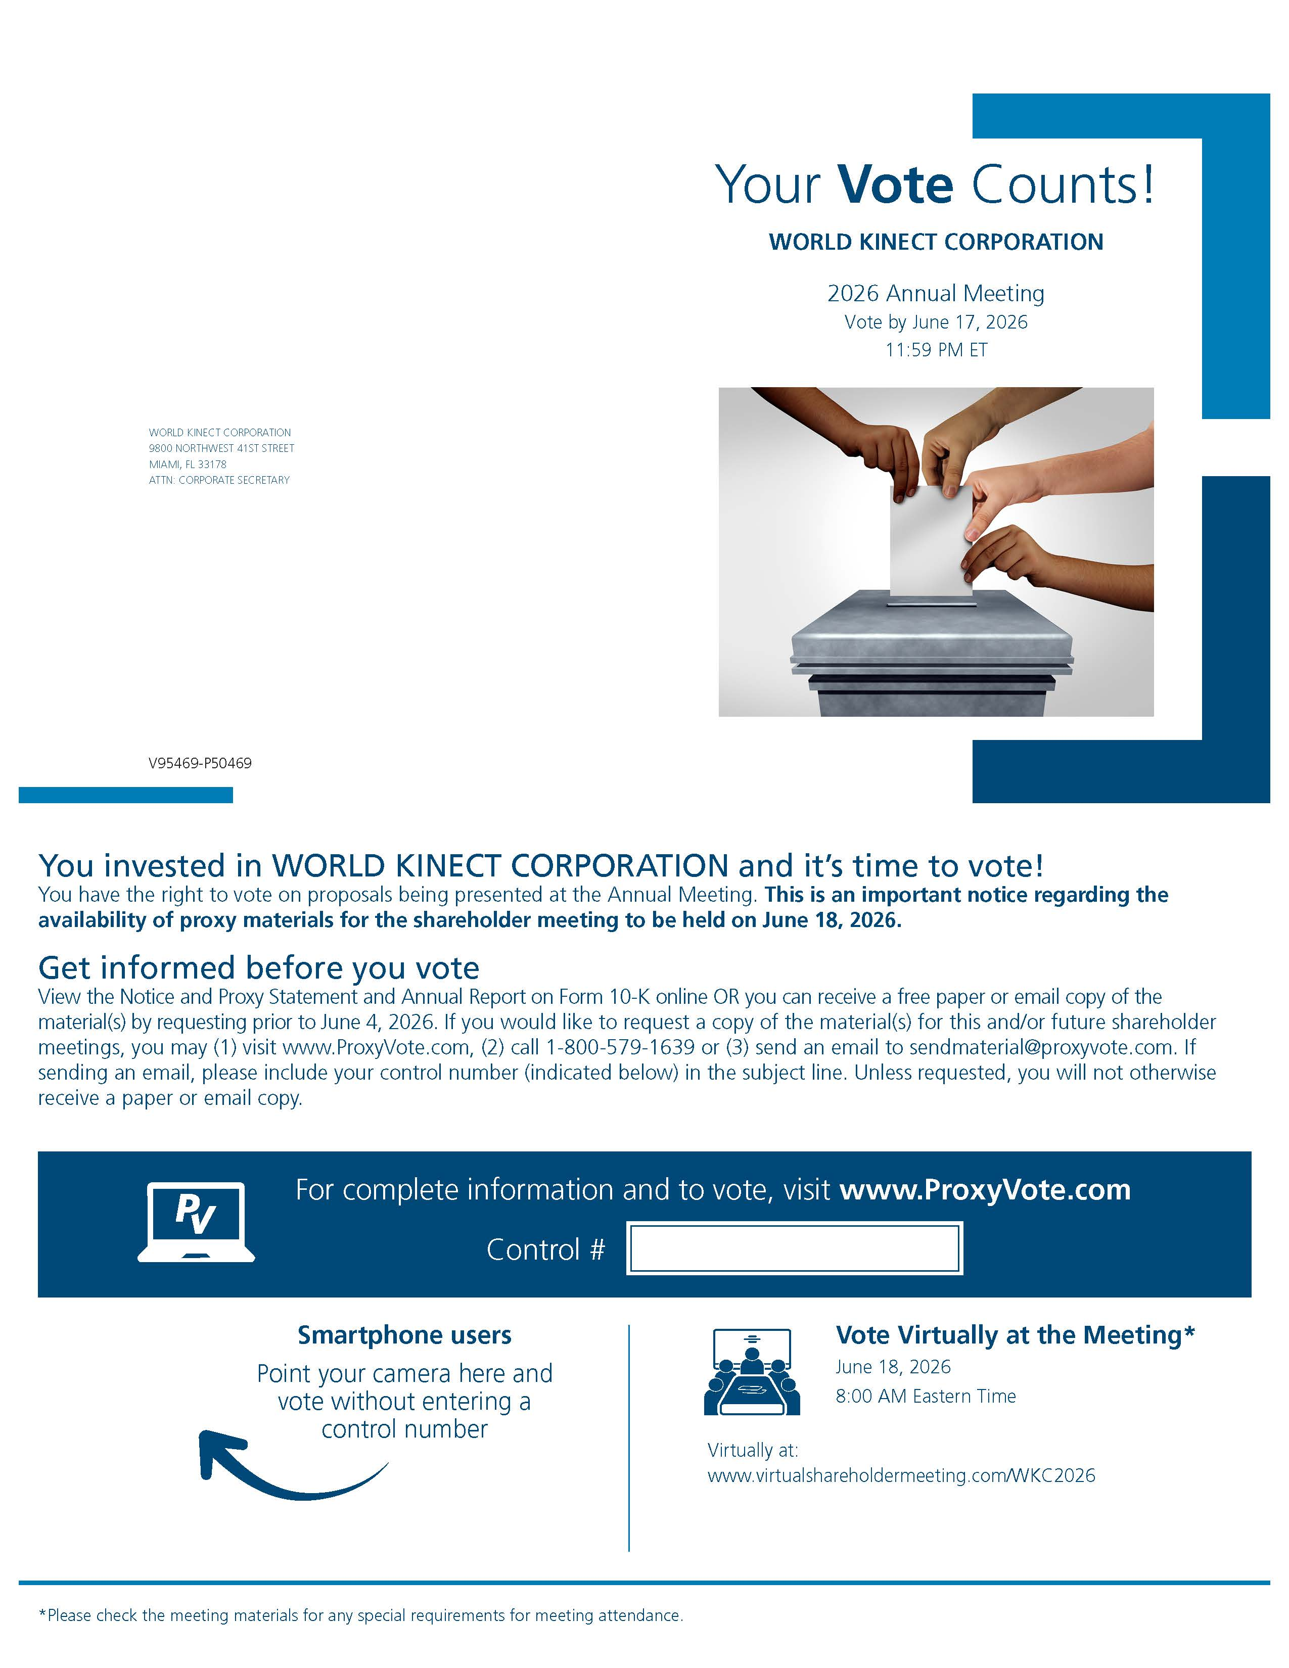 Your Vote Counts! WORLD KINECT CORPORATION 2026 Annual Meeting Vote by June 17, 2026 11:59 PM ET WORLD KINECT CORPORATION 9800 NORTHWEST 41ST STREET MIAMI, FL 33178 ATTN: CORPORATE SECRETARY V95469-P50469 You invested in WORLD KINECT CORPORATION and it’s time to vote! You have the right to vote on proposals being presented at the Annual Meeting. This is an important notice regarding the availability of proxy materials for the shareholder meeting to be held on June 18, 2026. Get informed before you vote View the Notice and Proxy Statement and Annual Report on Form 10-K online OR you can receive a free paper or email copy of the material(s) by requesting prior to June 4, 2026. If you would like to request a copy of the material(s) for this and/or future shareholder meetings, you may (1) visit www.ProxyVote.com, (2) call 1-800-579-1639 or (3) send an email to sendmaterial@proxyvote.com. If sending an email, please include your control number (indicated below) in the subject line. Unless requested, you will not otherwise receive a paper or email copy. For complete information and to vote, visit www.ProxyVote.com Control # Vote Virtually at the Meeting* June 18, 2026 8:00 AM Eastern Time Virtually at: www.virtualshareholdermeeting.com/WKC2026 *Please check the meeting materials for any special requirements for meeting attendance.

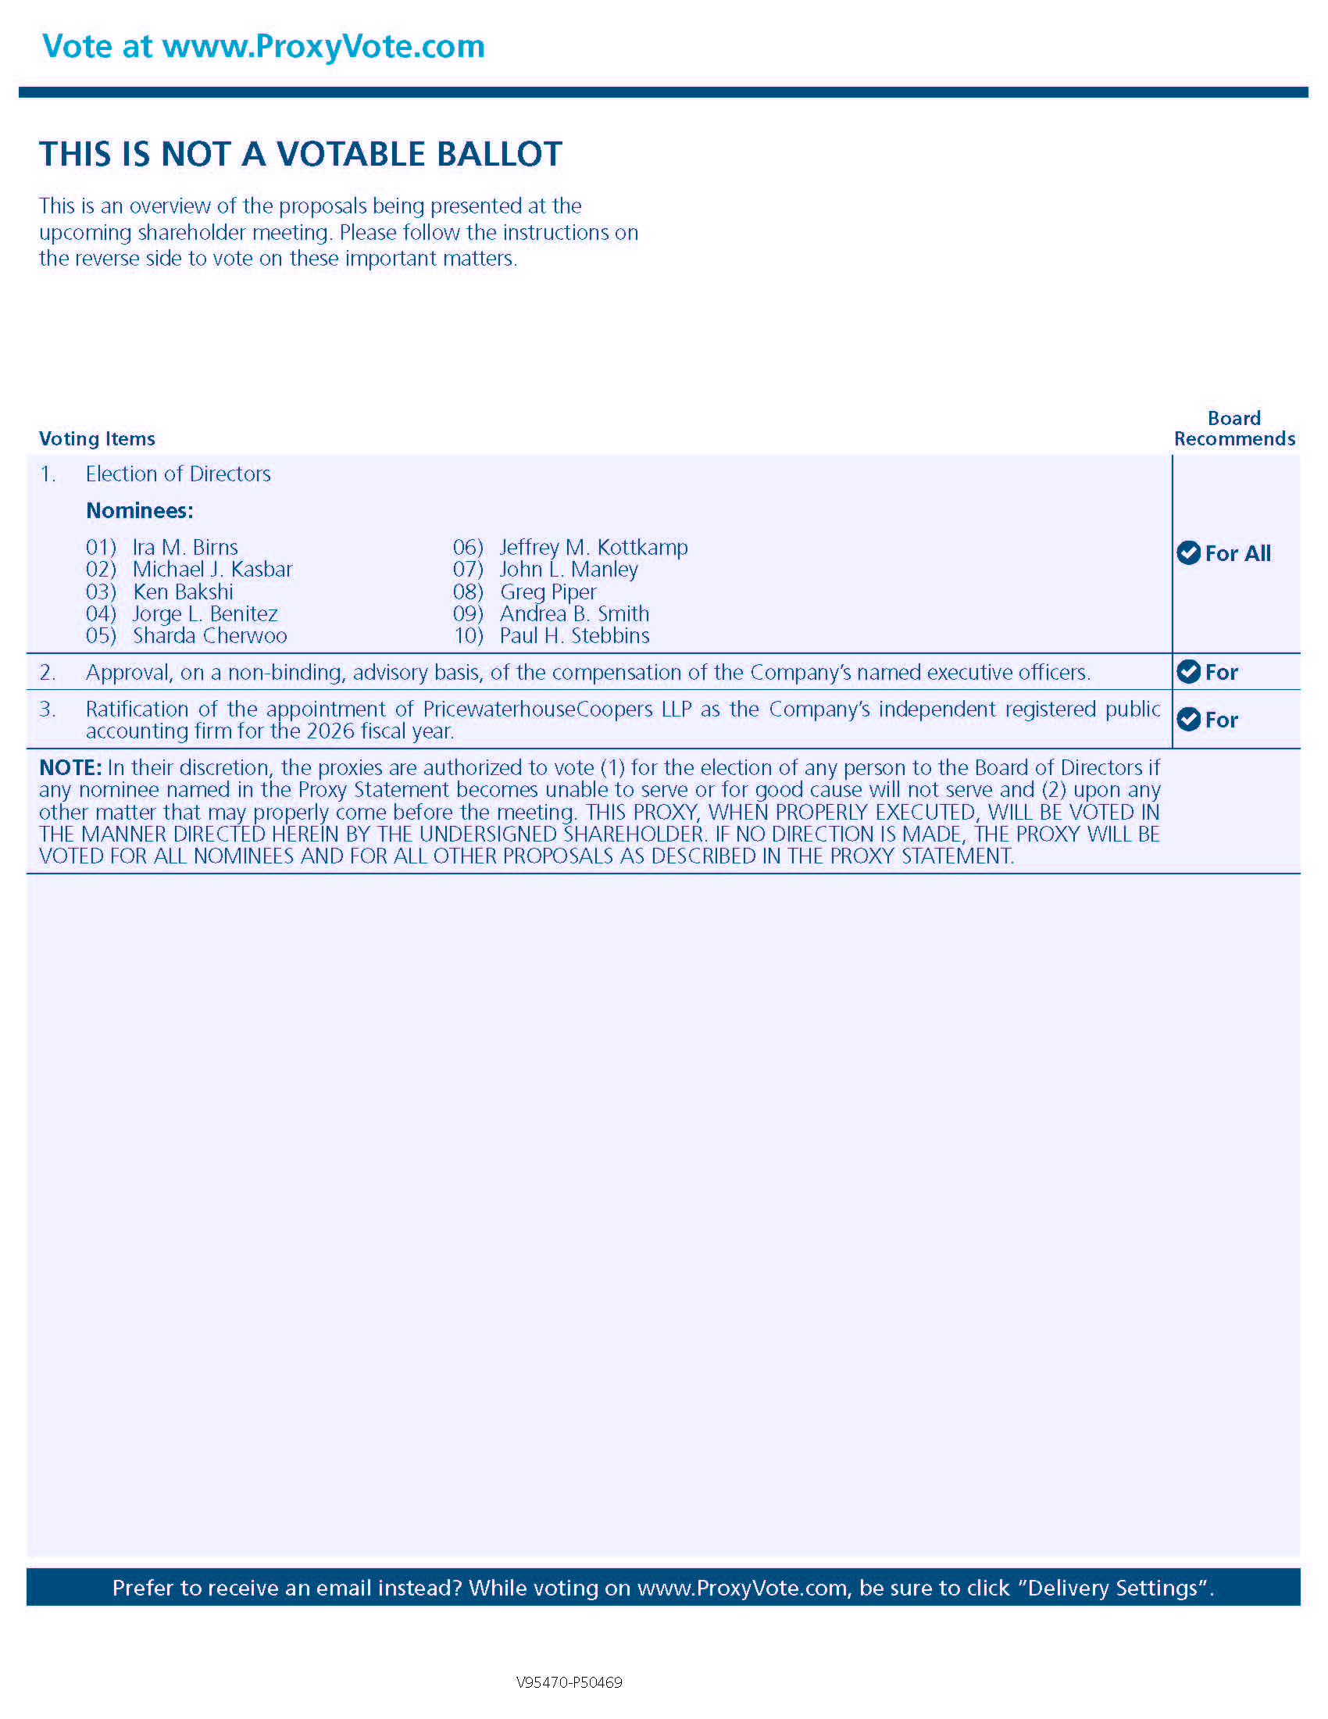Vote at www.ProxyVote.com THIS IS NOT A VOTABLE BALLOT This is an overview of the proposals being presented at the upcoming shareholder meeting. Please follow the instructions on the reverse side to vote on these important matters. Board Recommends Voting Items 1. Election of Directors For All Nominees: 01) Ira M. Birns 02) Michael J. Kasbar 03) Ken Bakshi 04) Jorge L. Benitez 05) Sharda Cherwoo 06) Jeffrey M. Kottkamp 07) John L. Manley 08) Greg Piper 09) Andrea B. Smith 10) Paul H. Stebbins 2. Approval, on a non-binding, advisory basis, of the compensation of the Company’s named executive officers. For 3. Ratification of the appointment of PricewaterhouseCoopers LLP as the Company’s independent registered public accounting firm for the 2026 fiscal year. For NOTE: In their discretion, the proxies are authorized to vote (1) for the election of any person to the Board of Directors if any nominee named in the Proxy Statement becomes unable to serve or for good cause will not serve and (2) upon any other matter that may properly come before the meeting. THIS PROXY, WHEN PROPERLY EXECUTED, WILL BE VOTED IN THE MANNER DIRECTED HEREIN BY THE UNDERSIGNED SHAREHOLDER. IF NO DIRECTION IS MADE, THE PROXY WILL BE VOTED FOR ALL NOMINEES AND FOR ALL OTHER PROPOSALS AS DESCRIBED IN THE PROXY STATEMENT. Prefer to receive an email instead? While voting on www.ProxyVote.com, be sure to click “Delivery Settings”. V95470-P50469

