UNITED STATES
SECURITIES AND EXCHANGE COMMISSION
Washington, D.C. 20549

SCHEDULE 14A
(Rule 14a-101)
Proxy Statement Pursuant to Section 14(a) of the Securities Exchange Act of 1934 (Amendment No. )

Filed by the Registrant | ☒ |  | Filed by a party other than the Registrant | ☐

Check the appropriate box:

☐ |  | Preliminary Proxy Statement
☐ |  | Confidential, for Use of the Commission Only (as permitted by Rule 14a-6(e)(2))
☐ |  | Definitive Proxy Statement
☒ |  | Definitive Additional Materials
☐ |  | Soliciting Material under § 240.14a-12

World Kinect Corporation
(Name of Registrant as Specified in its Charter)

(Name of Person(s) Filing Proxy Statement, if Other Than the Registrant)

Payment of Filing Fee (Check all boxes that apply):

☒ |  | No fee required
☐ |  | Fee paid previously with preliminary materials
☐ |  | Fee computed on table in exhibit required by Item 25(b) per Exchange Act Rules 14a-6(i)(1) and 0-11

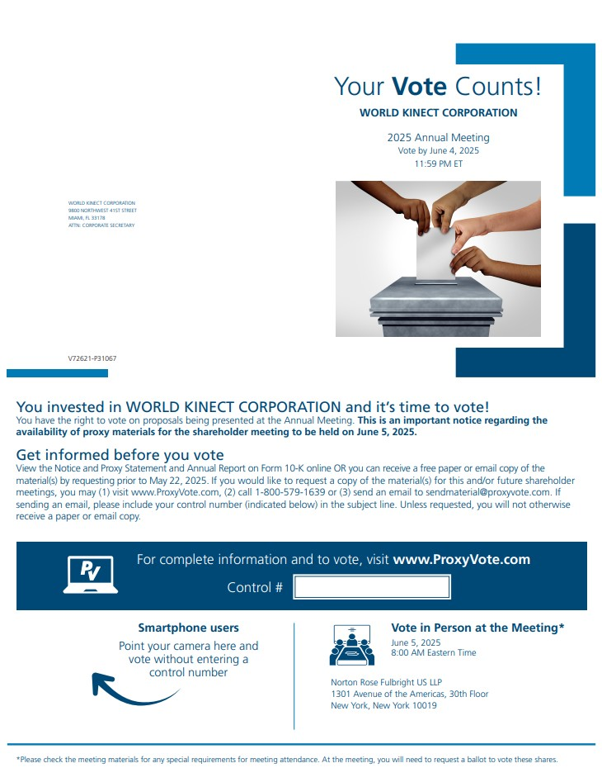
WORLD KINECT CORPORATION 9800 NORTHWEST 41ST STREET MIAMI, FL 33178 ATTN: CORPORATE SECRETARY Your Vote Counts! WORLD KINECT CORPORATION 2025 Annual Meeting Vote by June 4, 2025 11:59 PM ET V72621-P31067 You invested in WORLD KINECT CORPORATION and it’s time to vote! You have the right to vote on proposals being presented at the Annual Meeting. This is an important notice regarding the availability of proxy materials for the shareholder meeting to be held on June 5, 2025. Get informed before you vote View the Notice and Proxy Statement and Annual Report on Form 10-K online OR you can receive a free paper or email copy of the material(s) by requesting prior to May 22, 2025. If you would like to request a copy of the material(s) for this and/or future shareholder meetings, you may (1) visit www.ProxyVote.com, (2) call 1-800-579-1639 or (3) send an email to sendmaterial@proxyvote.com. If sending an email, please include your control number (indicated below) in the subject line. Unless requested, you will not otherwise receive a paper or email copy. For complete information and to vote, visit www.ProxyVote.com Control # Smartphone users Point your camera here and vote without entering a control number Vote in Person at the Meeting* June 5, 2025 8:00 AM Eastern Time Norton Rose Fulbright US LLP 1301 Avenue of the Americas, 30th Floor New York, New York 10019 *Please check the meeting materials for any special requirements for meeting attendance. At the meeting, you will need to request a ballot to vote these shares.

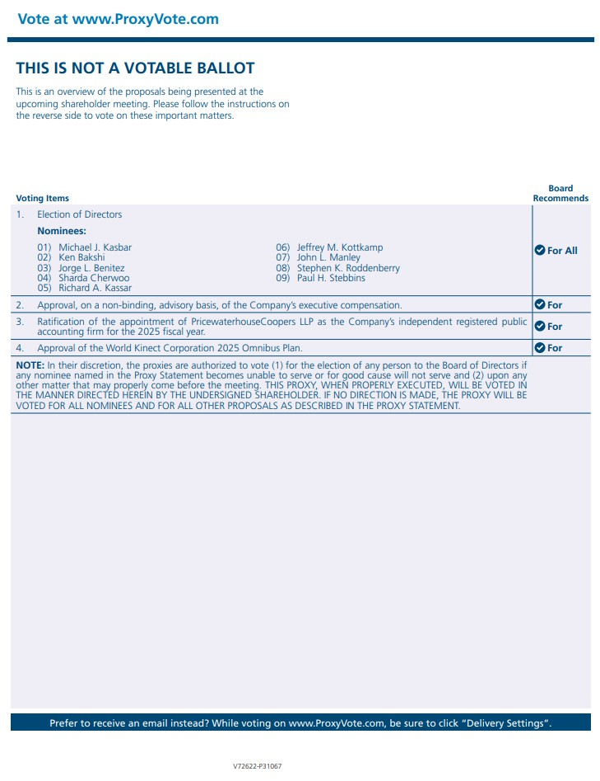
Vote at www.ProxyVote.comTHIS IS NOT A VOTABLE BALLOT This is an overview of the proposals being presented at the upcoming shareholder meeting. Please follow the instructions on the reverse side to vote on these important matters. Voting Items Board Recommends 1. Election of Directors For All Nominees: 01) Michael J. Kasbar 02) Ken Bakshi 03) Jorge L. Benitez 04) Sharda Cherwoo 05) Richard A. Kassar 06) Jeffrey M. Kottkamp 07) John L. Manley 08) Stephen K. Roddenberry 09) Paul H. Stebbins 2. Approval, on a non-binding, advisory basis, of the Company’s executive compensation. For 3. Ratification of the appointment of PricewaterhouseCoopers LLP as the Company’s independent registered public accounting firm for the 2025 fiscal year. For 4. Approval of the World Kinect Corporation 2025 Omnibus Plan. For NOTE: In their discretion, the proxies are authorized to vote (1) for the election of any person to the Board of Directors if any nominee named in the Proxy Statement becomes unable to serve or for good cause will not serve and (2) upon any other matter that may properly come before the meeting. THIS PROXY, WHEN PROPERLY EXECUTED, WILL BE VOTED IN THE MANNER DIRECTED HEREIN BY THE UNDERSIGNED SHAREHOLDER. IF NO DIRECTION IS MADE, THE PROXY WILL BE VOTED FOR ALL NOMINEES AND FOR ALL OTHER PROPOSALS AS DESCRIBED IN THE PROXY STATEMENT. Prefer to receive an email instead? While voting on www.ProxyVote.com, be sure to click “Delivery Settings”. V72622-P31067

